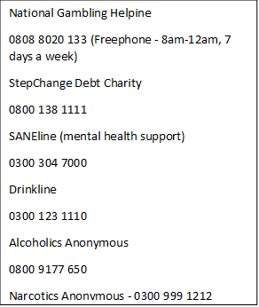

**SANEline**

(Mental health support)

**0300 304 7000**

**Alcoholics Anonymous**

**0800 9177 650**

**Narcotics Anonymous**

**0300 999 1212**

**National Gambling Helpline**

**0808 8020 133**

(Freephone - 8am-12am, 7 days a week)

**StepChange Debt Charity**

**0800 138 1111**

**Drinkline**

**0300 123 1110**

**Crisis numbers**

* **Call your GP** and ask for an emergency appointment
* **Contact your mental health crisis team** if available
* **Call CNWL out-of-hours urgent advice line** – 0800 0234 650
* **Call the Samartians –** 116 123 **or email** [jo@samaritans.org](mailto:jo@samaritans.org)
* **Call 111** out of hours (they can help if you have an urgent medical problem)

**In an emergency – call 999 or go straight to A & E, or ask somebody else to call 999 or take you to A & E**



**Gloucester’s Gambling Safety Information Card**

**I care very much about gambling addiction because it can affect people of all ages, and unlike most other addictions there are no physical signs. Things can go wrong fast, with real danger of people self-harming or even committing suicide.**

**So where to turn to for help? This is a list of helpful organisations and telephone numbers: please keep it handy or share with friends**

If you’re a Gloucester constituent and would like more guidance, please e mail me on [richard.graham.mp@parliament.uk](mailto:richard.graham.mp@parliament.uk) or ring 01452 501167

**Drinkline**

If you need more guidance on seeking help, please contact me – [richard.graham.mp@parliament.uk](mailto:richard.graham.mp@parliament.uk)